Posting Videos and large files via our
in-house Video hosting system (RosTube)
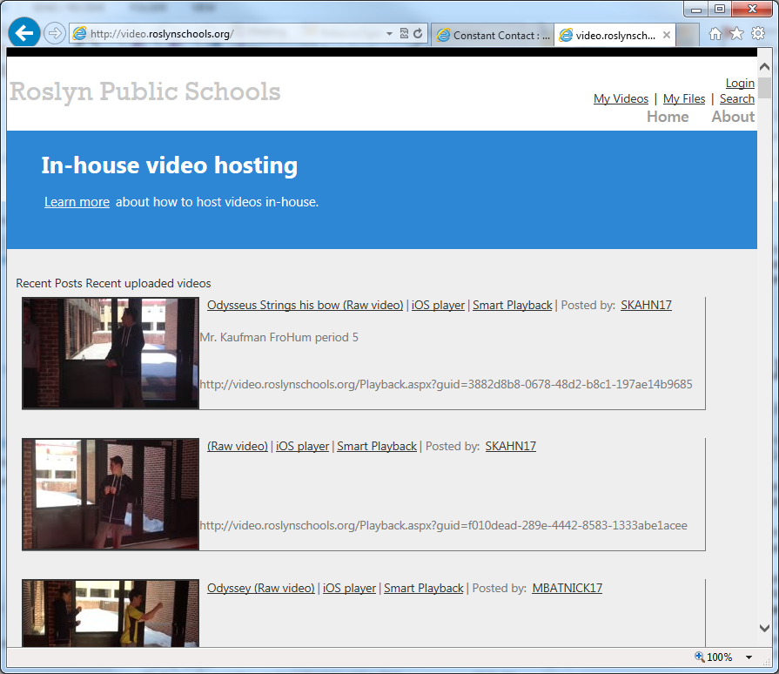

Login
  - Every user within our organization is already setup. To start, please click the login link on the upper right-hand corner. Login using your Roslyn user name and password.
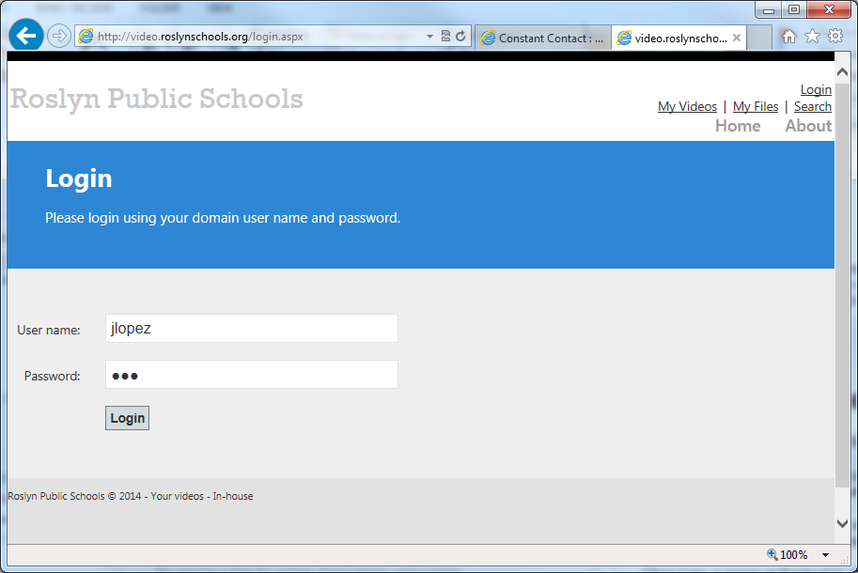

Post a video
- Once successfully logged in you can start posting videos or files.
  - Click the “Upload video” link on the left-hand side.
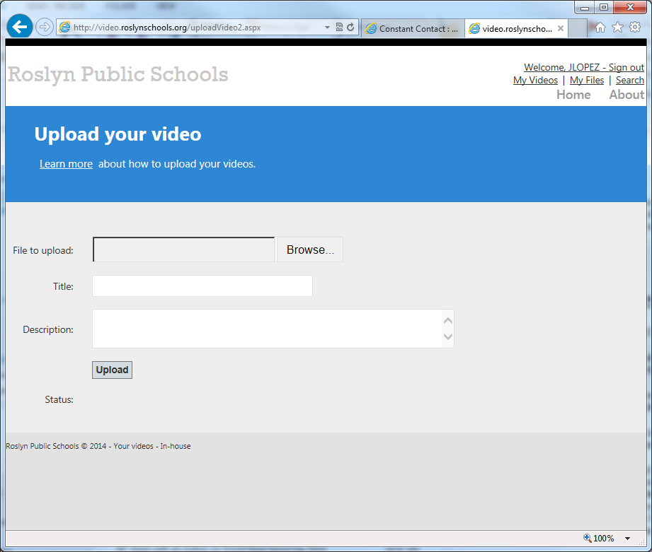
- Click the browse button to upload your video
- Enter a title and description for your video
- Once the File upload box turns green, you can click the upload button

Next step during class

Post a file

Sharing your video or file

Search for a video or file

